Example 1: Solve the system of linear equations using a matrix
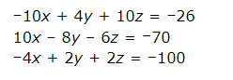

Example 2: Solve the system of linear equations using a matrix
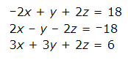

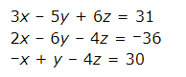
Example 3: Solve the system of linear equations using a matrix

